**Ideation Phase**

**Define the Problem Statements**

|  |  |
| --- | --- |
| Date | 17 October 2022 |
| Team ID | PNT2022TMID27330 |
| Project Name | Project – Signs with Smart Connectivity for Better Road Safety |
| Maximum Marks | 2 Marks |

**Customer Problem Statement Template:**

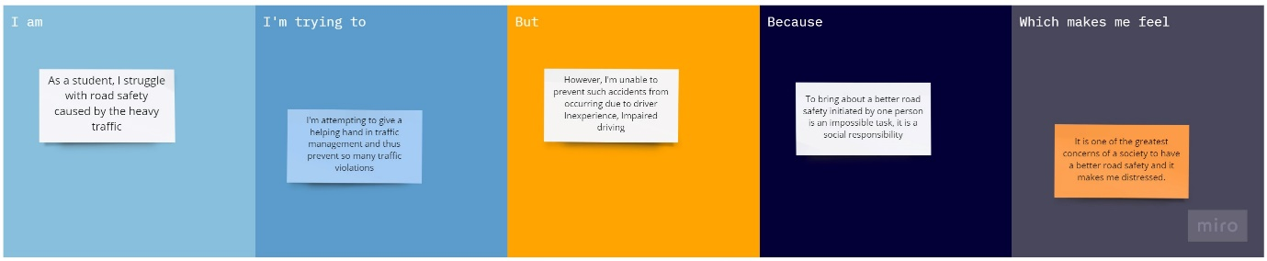

Reference: <https://miro.com/templates/customer-problem-statement/>

|  |  |  |  |  |  |
| --- | --- | --- | --- | --- | --- |
| **Problem Statement (PS)** | **I am (Customer)** | **I’m trying to** | **But** | **Because** | **Which makes me feel** |
| PS-1 | As a student, I struggle with road safety caused by the heavy traffic | I'm attempting to give a helping hand in traffic management and thus prevent so many traffic violations | However, I'm unable to prevent such accidents from occurring due to driver Inexperience, Impaired driving | To bring about a better road safety initiated by one person is an impossible task, it is a social responsibility | It is one of the greatest concerns of a society to have a better road safety and it makes me distressed. |
| PS-2 | As a senior citizen, I find it strenuous to drive in heavy traffic | I’m trying to acclimatize to this situation outside of the car | People don’t have the patience to drive beside us, they end up overtaking us which causes us to panic | As a senior citizen this change is new to us, and we are often expected to react quickly, to avoid unexpected turn of events | Driving has become a complex everyday task for me, which makes feel anxious while I’m driving. |